Presentation Requirements

You will also be responsible for preparing a 10 minute presentation.

****Poster board with github pages link

This will be a formal presentation.

One in which you explain in detail:

**Your overall application’s concept**

We created this website and formatted it specifically as a mobile web app. This web site will streamline important navigational links such as mortgage rate information, google maps neighborhood look up, request a call back, and a direct loan application to Mr. Malgieri’s employer’s website, branch locations and apply online which will grant him direct access.

**The motivation for its development**

The goal was to optimize the user experience via mobile, personalize it with info about Mr. Malgieri and provide simple quick access to any of his client current or future.

**Your design process**

We created a website mock up and wanted an impactful landing page that was straight to the point and easy to navigate.

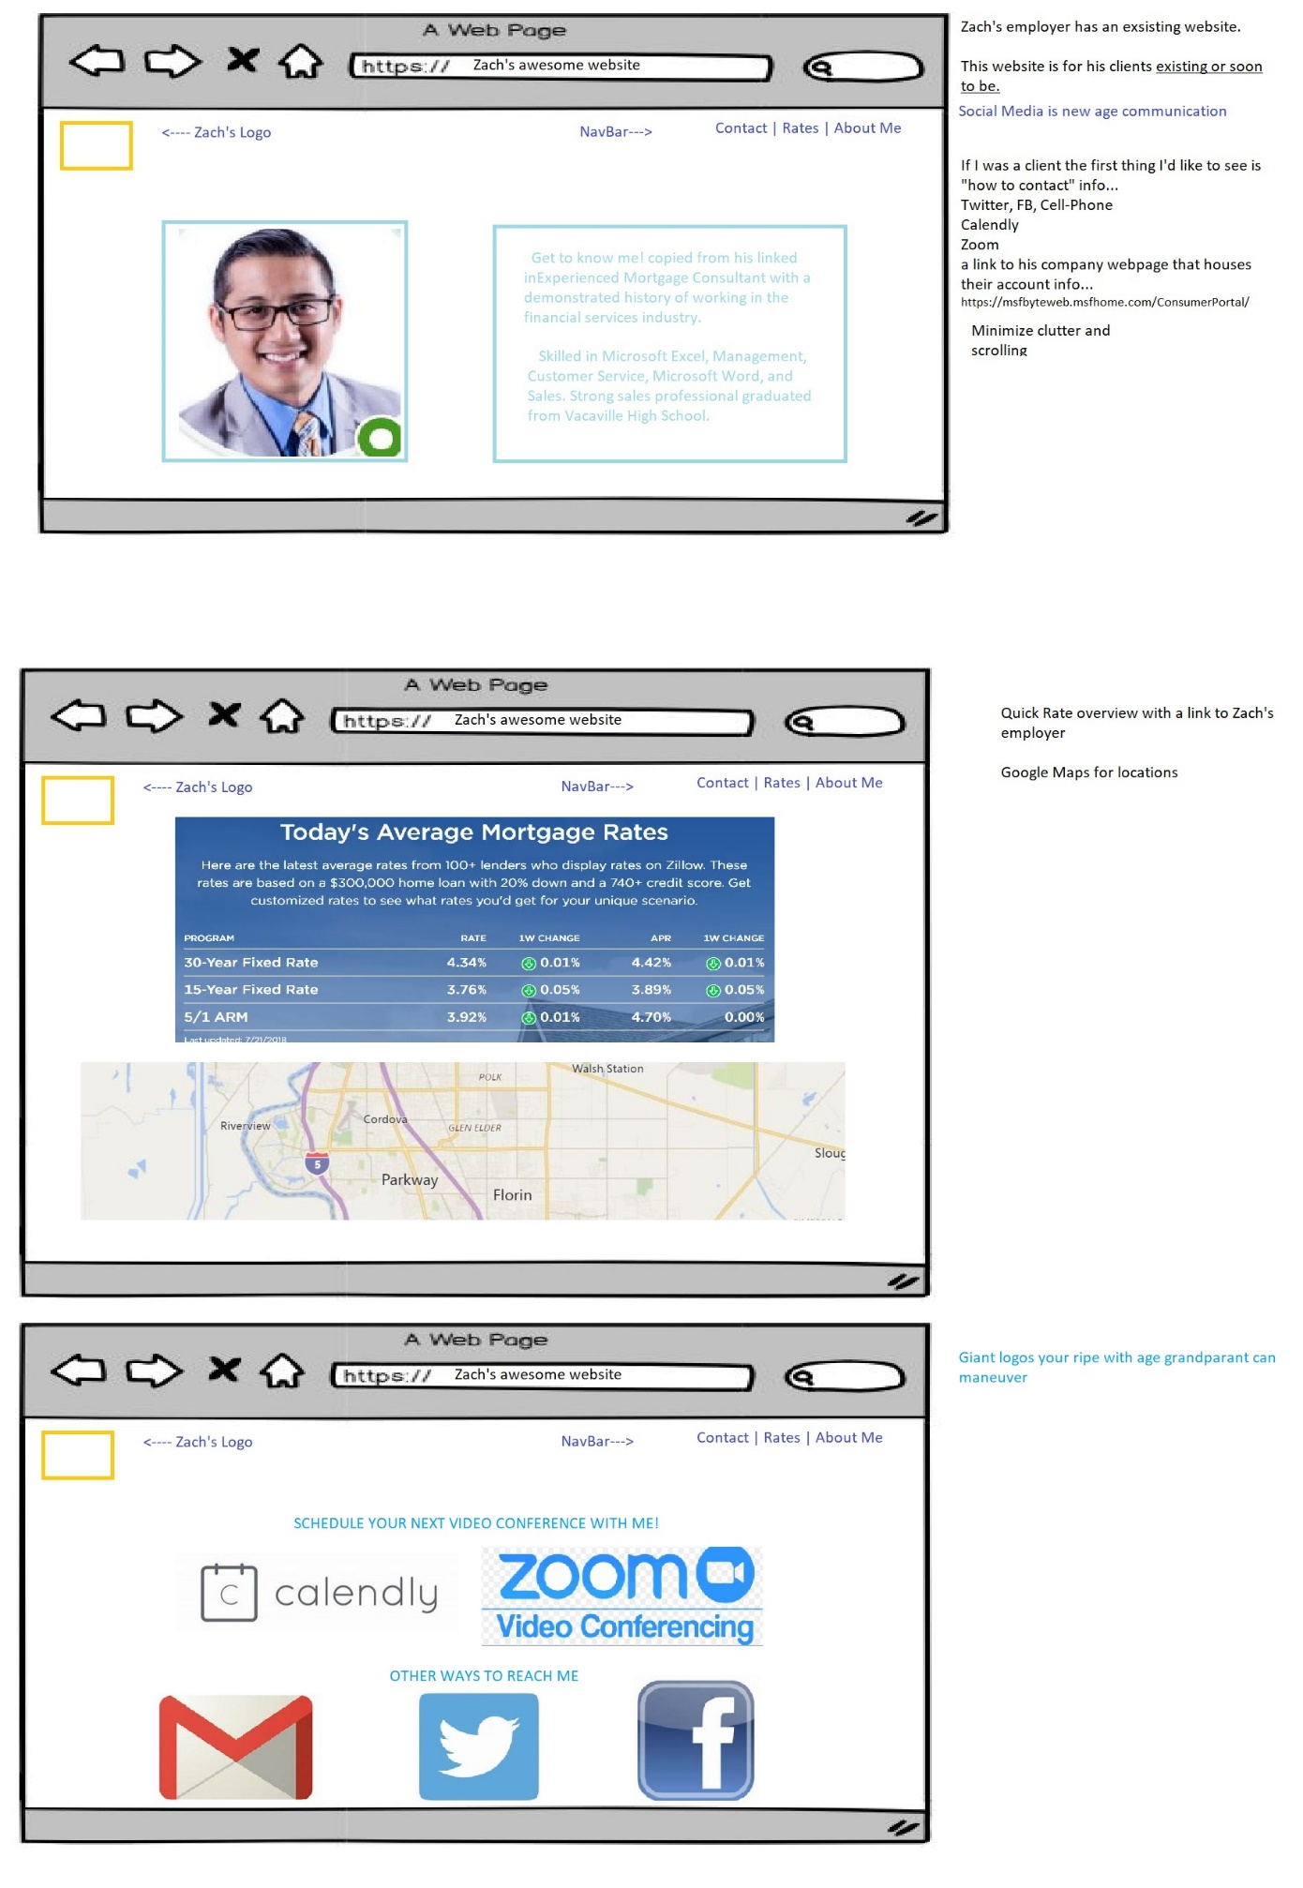

**The technologies you used (and briefly how they work)**

Firebase for Request call back form

Google API for………………………..

Materialize CSS Framework for styling and mobile browsing.

**A demonstration of its functionality**

**Directions for future development**

**Treat the presentation seriously!**